**Ideation Phase**

**Define the Problem Statements**

| Date | 19 September 2022 |
| --- | --- |
| Team ID | PNT2022TMID52569 |
| Project Name | Developing a Flight Delay Prediction Model using Machine Learning |
| Maximum Marks | 2 Marks |

**Example:**

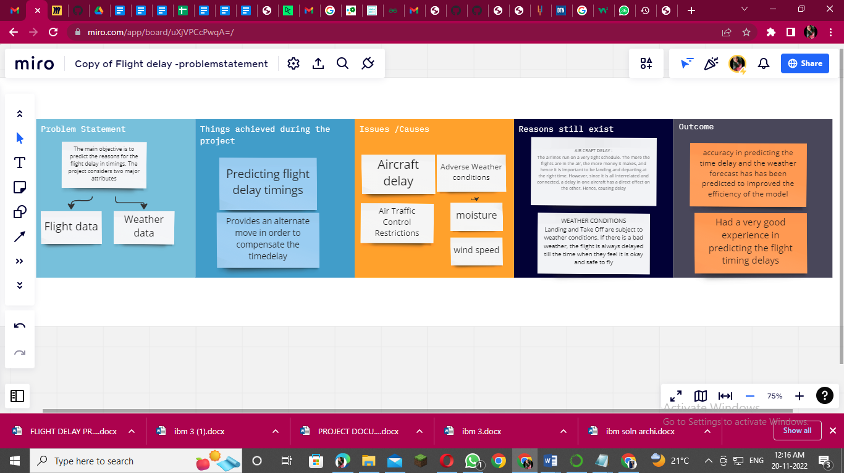

https://miro.com/app/board/uXjVPCcPwqA=/?share_link_id=343314141040